

**Renewable energy**

**COVID19 COMBATING INSTRUCTION**

This instruction has been prepared to publish the measures and rules to be taken within the scope of COVID-19 fight in our plants. The following rules must be fully implemented in all sites.

Scope

This instruction has been prepared to publish the measures and rules to be taken within the scope of COVID-19 fight in our plants. The following rules must be fully implemented in all sites.

* The responsibility for providing these instruction conditions in our plants rests with the Power Plant Manager.

Rights & Obligations

Responsibilities of Employer

**01.** Emergency action plan will be prepared against COVID-19 outbreak.

**02.** Activities and work organization carried out in the workplace will be tried to be organized in a way to prevent the exposure of employees to COVID-19.

**03.** Employee representatives and employees will be informed about the updated emergency plan and it will be ensured that they are aware of what they should or should not do within the scope of the plan.

**04.** CASE INQUIRY FORM given in Annex 1 shall be applied to all employees.

**05.** Cleaning agents specified in Annex 2 shall be kept available.

**06.** Announcements specified in ANNEX 3 shall be published on the sites. These announcements will also be communicated to all employees through digital platforms.

**07.** A separate risk assessment or an update on the existing risk assessment will be made to identify workplace specific hazards related to COVID-19.

**08.** Employees and visitors will be checked with contactless temperature meter, those with fever (≥38OC) will not be accepted to the field and will be directed to the emergency departments with masks and gloves. This situation shall be recorded IN COVID-19 RISK PERSONNEL DETERMINATION FORM (Annex 05) and the said form shall be communicated to the plant managers. Entrance controls shall be carried out outdoors at the entrance of the control building.

**Measurement distance (max)**

**SURFACE TO SCAN**

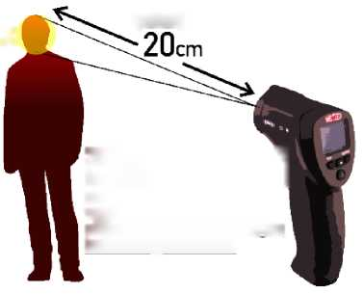

In **case of detection of fever 1 above 38oC**, access to the working I site shall not be permitted. Emergency service will be provided with mask and gloves!

**The Security Officer who carried out the checks, you should always wear gloves, mask and protective glasses**

In the areas where the said controls are carried out, the posters specified on the next page shall be established.

 Individuals who show strength that does not allow controls cannot be accepted to the power plant site.

Picture 1 INSPECTION POST POSTER DESIGN

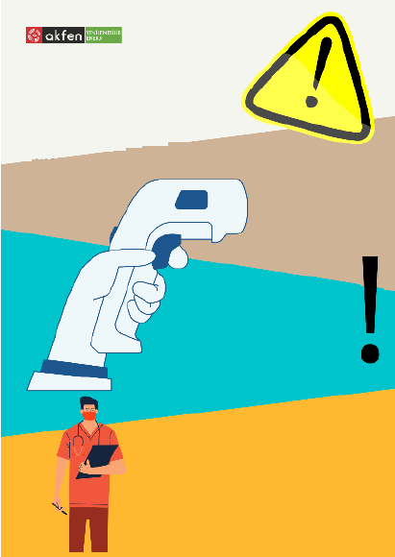

**Stop Spreading!**

**CHECK POINT!**

Before entering our plant; you will be subjected to non-contact temperature measurement!

**All individuals, including our employees, will be subjected to temperature measurement with non-contact measuring devices before** entering our power plant site.Within the scope of COVID-19 CONTROL INSTRUCTION, individuals with a body temperature above **38** C will be directed to the nearest hospital that will not be accepted to our plant.

Pay attention to other symptoms!!!

**COVID-19 symptoms are fever, cough, difficulty breathing and weakness.**

**09.** Warning posters will be established to protect the social distances of the employees throughout the workplace and our employees will be made aware of this issue and warned if necessary.

Figure 2 GENERAL WORKING RULES AGAINST PANDEMIC POSTER DESIGN

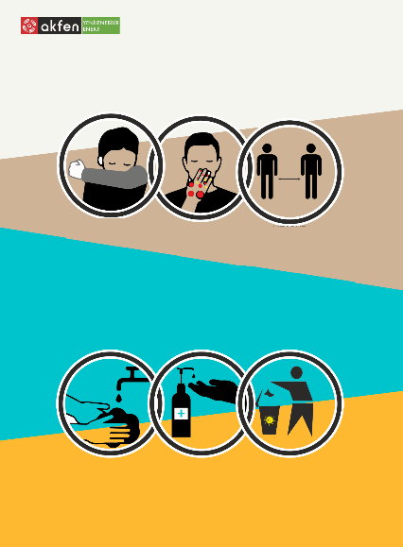

**Stop Spreading!**

**General working rules against the pandemic!**

|  |  |  |
| --- | --- | --- |
| DURING COUGHING & SNEEZING, THE MOUTH AND NOSE SHOULD BE CLOSED WITH DISPOSABLE PAPER HANKERCHIEFS.  IF NOT, USE THE INTERNAL PART OF YOUR ELBOW! | DO NOT TOUCH AT YOUR MOUTH, NOSE AND EYES WITH YOUR HANDS!  KEEP AWAY FROM ACTIONS CONTAINING CONTACT SUCH AS HANDSHAKE ETC. | MAKE SURE TO KEEP A3-4 STEP DISTANCE BETWEEN YOU AND OTHER PERSON ONLY UNLESS YOU HAVE TO! |

|  |  |  |
| --- | --- | --- |
| YOU SHOULD WASH YOUR HANDS THOROUGHLY USING WATER AND SOAP FOR AT LEAST 20 SECONDS! | USE DISINFECTANT TO CLEAN YOUR HANDS WHEN YOU DO NOT USE WATER/SOAP! | DISPOSE OF YOUR MASK, GLOVES, HANKERCHIEFS ETC. TO THE COVERED WASTE BOXED DESIGNATED FOR SUCH WASTES. |

**010.** Posters containing cough and sneezing etiquette and explaining the importance of hand hygiene will be hung at the entrance of the workplace and other areas where everyone can see. Training videos on the correct hand washing techniques will be forwarded to all personnel.

Picture 3 QR CODE - HAND HYGIENE TRAINING



**011.** Disinfectants shall be installed at the entrance of the work areas. The use of these disinfectants shall be ensured at the entrances and exits of the site.

Figure 4 DISINFECTANT USE WARNING POSTER DESIGN

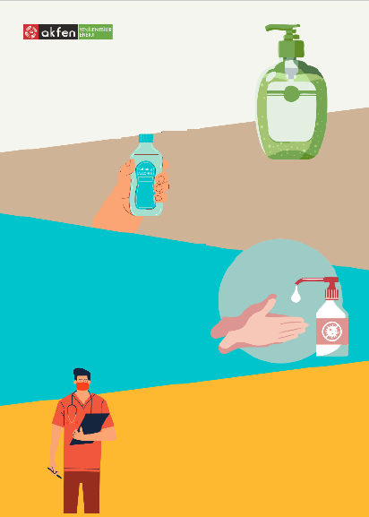

**Stop Spreading!**

**DISINFECTANT USE**

Please disinfect your hands before entering our plant!

How does hand sanitizer work? What is Method?

In the event of visible or invisible contamination, hand sanitizer is used to prevent micro-organisms that cause disease from infecting our body or others or contaminating surfaces. They are the most frequently and safely used alcohol-based hand sanitizers.

How Hand Disinfectant is Applied Will It Be Effective? What is the Method?

For it to be effective, the palm needs to be filled and the hand needs to be rubbed and spread between the palms and the outside of the hand, covering the wrists. Since it can evaporate in a very short time and kill bacteria and viruses within 2 seconds, it needs to spread quickly over the hand.

WARNIG: We should not inhale any disinfectant while disinfecting our hands because it may be harmful to the respiratory tract due to its content

**Do Disinfectants Absolutely Eliminate the Virus?**

Most disinfectants are effective against harmful viruses. These are effective in most disease-causing viruses, spore-free actors, such as HIV, Hepatitis B, influenza, or Coronavirus.

In this context, the areas where disinfectant will be kept are listed below.

o Control building entry points

o Inside the control room

o In office rooms

o In warehouse areas

o Within company vehicles

**012.** Employees will be provided with medical waste garbage bags for disposable tissues and biological waste; personnel performing the cleaning will be informed to empty the garbage without contacting the content of the garbage.

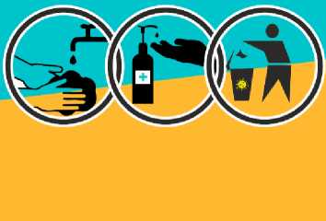

|  |  |  |
| --- | --- | --- |
| YOU SHOULD WASH YOUR HANDS THOROUGHLY USING WATER AND SOAP FOR AT LEAST 20 SECONDS! | USE DISINFECTANT TO CLEAN YOUR HANDS WHEN YOU DO NOT USE WATER/SOAP! | DISPOSE OF YOUR MASK, GLOVES, HANDKERCHIEFS ETC. TO THE COVERED WASTE BOXED DESIGNATED FOR SUCH WASTES. |

**013.** Employees will be informed to wash their hands with soap and water before entering the workplace environment and for at least 20 seconds during work, and if there is no access to soap and water, hands will be cleaned frequently using an alcohol-based hand disinfectant.

Picture 5 DIGITAL INFORMATION_01 (ALL EMPLOYEES) PICTURE 6 DIGITAL INFORMATION_02 (ALL EMPLOYEES)

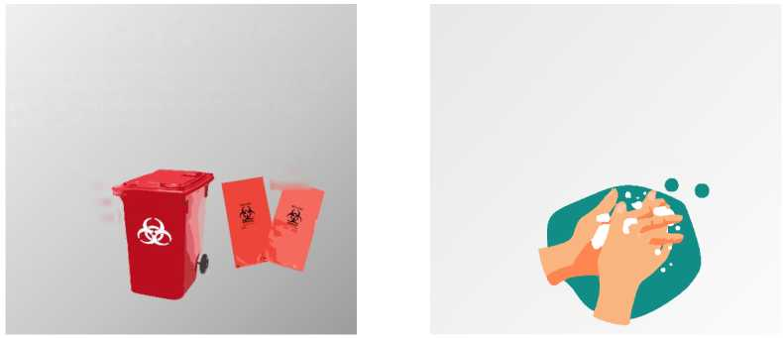

*HAND WASHING*

*Please wash your hands thoroughly frequently*, for **at** least *20 seconds on your elbows, wash your hands thoroughly above, between your fingers, under your nails.*

*WASTE MANAGEMENT*

*All wastes such as handkerchiefs etc. used for your cough will be bio-waste. Dispose of waste to designated of waste bins. Do not throw it out or into other waste bins! .*

**Biological Waste Box (Covered)**

**Biological waste bag**

**014.** Sufficient cleaning materials shall be kept available for the use of employees in the workplace. Keeping disinfectants in common areas to promote hand hygiene.

**015.** Liquid soap shall be installed in sinks and toilets. Use of solid soap shall not be allowed.

**016.** All sites and vehicles shall be disinfected periodically (at least once a month) in accordance with ANNEX 06 DESENSFECTION INSTRUCTION.

**017.** If an employee is identified as having COVID-19, other employees will be informed about their likelihood of being exposed to COVID-19 and healthcare institutions will be contacted.

**018.** In order to protect the mental health of employees, psychosocial risk factors will be evaluated, and measures will be taken with accurate and effective information.

**019.** Reliable sources of information (such as the Ministry of Health, WHO) will be used to monitor current information.

**020.** Occupational health and safety trainings to be given to the employees will be given priority in the form of distance education, workplace cleaning and order, hygiene and psychosocial risk factors.

**021.** Suggestions about family and social life will be included in the trainings.

**022.** Necessary additional measures shall be taken in line with the recommendations of the Ministry of Health.

**023.** Keeping close contact with the employees as much as possible in the workplaces and the common use of equipment, tools and equipment will be prevented.

**024.** Regular cleaning practices will be maintained, including routine cleaning and disinfection of surfaces, equipment and other elements of the working environment. In this context, it will be ensured that all employees clean their own office environments on a daily basis and general indoor cleaning will be carried out at least once a week.

**025.** Employees will be trained in hands-on effective hand washing. Their awareness on hand cleaning and hygiene will be increased. (Digital training videos, etc.)

Picture 7 HAND WASHING TRAINING QR CODE



**026.** Visits to other study areas will be restricted, non-urgent visits and non-urgent services from outside will be cancelled.

**027.** Everyone who visits the workplace will have access to hand washing facilities.

**028.** Managers will set an example for their employees as they play an important role in determining the right example.

**029.** ANNEX4 “CORONA MEASURES RELATED TO DRIVING" rules regarding the use of vehicles shall be taken into operation.



Annex 04

CORONA MEASURES FOR DRIVING

**030.** The workplace will be ventilated at regular intervals. No air free environments shall be allowed.

**031.** If it is not possible, a numbering system will be provided to ensure that employees eat in shifts, that employees who will eat at the same time can sit at a distance or that the employee sits at the same table every day.

**032.** The use of common water dispenser etc. kitchen equipment is prohibited. Water will be supplied in individual disposable pet bottles.

**033.** All equipment such as cups, cups etc. shall be specially allocated to persons (labeling, etc.). Individuals will only be asked to use the equipment such as glasses, cups, etc. delivered to them and not to touch the special equipment of others.

**034.** All personal equipment such as cups, cups etc. shall be kept in disposable refrigerator bags so that they do not all come into contact with each other.

**035.** Work garments and protective equipment must be removed before leaving the work area and kept separately from other garments. Cleaning of contaminated clothing and protective equipment will be ensured by removing the virus and disposing if necessary.

**036.** In working environments where there is a risk of direct contact or contamination with persons suspected of infection, it will be ensured that employees wear fully closed eye protection or face protection/visor (EN-166), protective clothing (EN-14126), respiratory protection (EN-149/FFP2 or FFP3) without ventilation masks and gloves (EN ISO 374-5 and virus pictogram). Masks marked “NR”, meaning “not reusable”, must be kept available for protection against the Covid-19 virus.

**037.** Employees will be provided with waste management trainings within the scope of "Circular 2020/12 on Covid-19 Measures in the Management of Personal Hygiene Material Wastes such as Disposable Masks and Gloves" by occupational health and safety experts in the workplaces and their awareness on hygiene will be increased.

**038.** Meetings will be postponed or teleconferenced to prevent exposure to COVID-19. If not possible, the meeting will be held with fewer participants.

**039.** The following issues will be taken into account to prevent infection at the meeting or event;

**a.** Ensuring cleaning and ventilation before, during and after the meeting.

**b.** Adequate supplies will be provided for all participants, including handkerchiefs and hand sanitizer.

**c.** Greetings will be ensured without shaking hands at the beginning of the meeting.

**d.** Ensure that all participants use hand washing or alcoholic disinfectant regularly at the meeting or event.

**e.** Placing hand disinfectant devices in meeting places in a way that can be easily seen and used by everyone.

**f.** A seating arrangement will be arranged so that there will be an appropriate distance between the participants.

**g.** Meeting, event areas will be ventilated periodically. The formation of an airless environment will not be allowed.

**h.** At the end of the meeting, saying goodbye without shaking hands and collective photos will not be taken.

**040.** Closed COVID-19 SUSPICION area shall be created. If there is a suspicion of illness among the employees, the said individual will be given a mask immediately, he/she will be encouraged to use it and COVID 19 will be rested in the area of suspicion. When necessary, close contact with the individuals in question will be discontinued, a distance of 2 meters will be maintained continuously during communication, besides;

**a.** The transfer of the said employee to the EMERGENCY LEVEL as soon as possible shall be carried out in accordance with the EMERGENCY ACTION PLANS. (Exercise should be carried out in this regard.)

**b.** It will be ensured **that the devices and equipment used by the individual in question are cleaned by an employee** whose personal protective equipment specified below is equipped. Personnel performing the cleaning process should clean all limbs that are at risk of contact with liquid soap and alcohol-based antiseptics after the procedure.

PERSONAL PROTECTORS TO BE USED IN CASES WHERE IT IS MANDATORY TO BE IN THE SAME ENVIRONMENT WITH SUSPICIOUS INDIVIDUALS OR DURING CLEANING OPERATIONS;

I. GLOVES

**TS EN ISO 374-5**: Protective gloves against hazardous chemicals and micro-organisms - Part 5: Terms and performance rules for risks involving microorganisms

II. APRON (NON-STERILE, PREFERABLY LIQUID PROOF AND LONG SLEEVE)

**TS EN 14126**: Protective clothing - Performance rules and testing methods for protective clothing against infectious agents

III. MINIMUM N95/FFP2 MASK

**TS EN 149+A1**: Respiratory protective devices- Half masks with filters for protection against particles - Features, tests and marking.

This standard covers the minimum characteristics of half-masks with filters from respiratory protective devices used to protect against particles in situations that cannot be moved away from the environment.

IV. GOGGLES

**TS 5560 EN 166**: Personal eye protection - Features

This standard covers functional features of different types of personal eye protectors.

**041.** All employees will be given a consent to work within the framework of the conditions and rules in question. Employees who do not sign the said deed of consent will not be allowed to enter the site.

Additional responsibilities for kitchen/cafeteria use

Employees will be informed about the following issues and the necessary facilities will be provided in full.

**042.** Each dining table and chair will be cleaned before use.

ANNEX 02 TABLE 1 CHEMICALS TO BE USED IN ENVIRONMENTAL CLEANING

**043.** All employees will wash their hands before entering the kitchen.

**044.** If possible, the employees will use the kitchen in turn, they will not eat at the same time, if this is not possible, the distance between the chairs will be positioned at least 100 cm.

**045.** There shall be disinfectant on the dining tables.

**046.** Common products such as saltshakers and spices will be removed from use. Instead, packaged disposable salt and spices will be used.

**047.** Common materials such as water dispenser, jug etc. shall be removed from use. Instead, packaged personal water will be used.

**048.** Open powder, sugar cubes shall not be used. Single wrapped sugar cubes will be used.

**049.** Employees should use the items such as cups, cups etc. allocated to them and should not come into contact with such items belonging to others. Equipment such as cups, cups etc. shall be kept separately from each other and in refrigerator bags. Refrigerator bags will be replaced after each use. Disposable paper cups will be used in areas where this is not possible.

**050.** Guests are prohibited from using existing cups and cups. Disposable paper cups shall be used when necessary.

**051.** Each dining table, chair will be cleaned by users after use.

**052.** Kitchens, cafeterias will be ventilated before and after use.

**053.** Kitchen cleaning will be recorded with the help of cleaning schedules.

**054.** Cooking will be prohibited in our plants.

The poster whose design is given below shall be installed in the kitchen and dining hall areas.

Picture 8 ADDITIONAL RULES FOR KITCHEN/DINING HALLS



**Stop Spreading!**

**Additional Rules for Kitchen/ Dining Rooms**

• The dining table chair will be cleaned before use.

• All employees will cut their hands before entering the kitchen.

• If possible, the employees will use the kitchen in turn, they will not eat at the same time, if this is not possible, the distance between the chairs will be positioned at least 100 cm.

• Disinfectant shall be kept on dining tables.

• Common products such as saltshakers and spices will be removed from use. Instead, packaged disposable salt and spices will be used.

• Common materials such as water dispenser jugs etc. shall be removed from use. Instead, packaged personal water will be used.

• Open powder, sugar cubes shall not be used. It will use packaged single wrapped sugar cubes

• Employees should use the items such as cups, cups etc. allocated to them and should not come into contact with such items belonging to others. Equipment such as cups, cups etc. shall be kept separately from each other and in refrigerator bags. Refrigerator bags will be replaced after each use. Disposable paper cups will be used in areas where this is not possible.

• Guests are prohibited from using existing cups and cups. Disposable paper cups shall be used when necessary.

• Each dining table chair will be cleaned by the users after use.

• Kitchens and cafeterias will be ventilated before and after use.

• Kitchen cleaning will be recorded with the help of cleaning schedules.

• It is prohibited to cook in our plants.

Management of Personal Hygiene Material Wastes such as Disposable Masks, Gloves

The requirements of Circular 2020/12 on Covid-19 Measures in the Management of Personal Hygiene Material Wastes such as Disposable Masks and Gloves shall be fulfilled in full. In this context, the necessary additional waste bins shall be supplied and installed.

<https://webdosya.csb.gov.tr/db/cygm/icerikler/gng2020-16-cov-d-19-20200408101457.pdf>

Employee Responsibilities

**01.** If you encounter the following situations, you must immediately inform your manager by phone and act in accordance with your manager's instructions.

**a.** At least one of the signs and symptoms of fever or acute respiratory disease (cough and respiratory distress)

**b.** Interviewing individuals from abroad, close contact,

**c.** Diagnosing COVID-19 in the individuals you are interviewing

**02.** Controls such as temperature measurement etc. will be allowed during employment. The work site shall not be entered without performing the said controls.

**03.** Wash hands with soap and water for at least 20 seconds before starting work. In addition, hands will be cleaned frequently with alcohol containing disinfectant. Employees will first wash their hands before and after each break, which will be repeated frequently throughout the day.

**04.** In case of encountering individuals who do not clean their hands regularly, it is necessary to warn and report the situation to the supervisor. All employees are expected to show sensitivity in this regard.

**05.** Surface contact shall be avoided as much as possible in common areas of use such as work areas, sinks, toilets, bathrooms, stair railings, taps and dining halls, resting areas, dressing/changing rooms, doors, turnstiles.

**06.** Keyboards and other devices will be cleaned by users before and after use.

**07.** Employees shall not use other employees' phones, desks, offices or other working tools and equipment as much as possible.

**08.** In cases of coughing and sneezing, the mouth and nose will be closed with a disposable handkerchief, and in cases where handkerchief is not used, the inner side of the elbow will be used.

**09.** Hands should not be contacted to the facial area.

**010.** When it is necessary to use a vehicle, CORONA MEASURES (ANNEX 4) regarding the use of vehicle shall be followed.

**011.** Work garments and protective equipment shall be removed before leaving the work area and kept in the specified area. Contaminated disposable clothing and protective equipment shall be disposed of in a dedicated waste bin. No PPE will be thrown around or in any garbage (e.g. mask, gloves, goggles, etc.).

**012.** Apart from the obligations, at least 1.5 meters distance shall be left with other employees.

**013.** Wipes and hand sanitizers will be used frequently during the study. Used wipes shall not be thrown on the table or on the floor. It will be disposed of in the designated waste bin after use.

**014.** Employees are prohibited from using dispensers, common bottles, etc. Water need shall be provided with disposable pet skewers.

**015.** Employees should use the items such as cups, cups etc. allocated to them and should not come into contact with such items belonging to others. Equipment such as cups, cups etc. shall be kept separately from each other and in refrigerator bags. Refrigerator bags will be replaced after each use. Disposable paper cups will be used in areas where this is not possible.

**016.** Persons suspected of being sick shall be immediately notified to the managers and PERSONNEL with COVID-19 RISK shall be informed via mobile phones by filling out the DETERMINATION FORM.

**017.** If individuals suspected of being sick are detected, COVID-19 EMERGENCY ACTION PLAN conditions will be followed.

**018.** Working environments shall be ventilated continuously. No air shall be allowed in indoor environments.

**019.** Prepared by the center and forwarded to your mobile phone;

a. The forms will be filled out without delay,

b. The information texts shall be read as soon as possible, and the instructions shall be fulfilled in full.

c. Training videos will be watched without delay.

**020.** The warning, information posters shall be read and applied.

**021.** Sufficient amount of disinfectant, mask, gloves, etc. In case PPE is not available, it shall immediately notify this situation to the center with mobile suggestion/complaint forms.

**022.** When first aides intervene in a possible emergency (injured rescue, etc.) Must use all personal protective equipment provided under COVID-19 (mask, gloves, goggles). This situation should be incorporated in INJURED RESCUE EMERGENCY ACTION plan.

* If a staff member who has been decided to be transferred to the hospital due to the suspicion of COVID 19 needs to be sent to the emergency department together with another employee, it is imperative that the driver completes and approves the SPECIAL TRANSFER OPERATION CONTRACT by signing it.

Picture 9 SUSPICIOUS TRANSFER POSITION ACCEPTANCE COMMITMENT

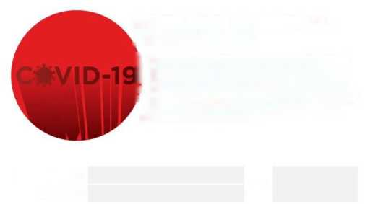

**TRANSFER PERFORMED**

**DATE OF TRANSFER**

**EXCUSE OF PERSON NOT TO USE**

SUSPICIOUS TRANSFER OFFICE ACCEPTANCE CONTRACT

This undertaking has been prepared to declare that individuals who are suspected ofCOVID-19/Coronavirus disease and who are determined not to be able to drive on their own, our employees who undertake the transfer to the emergency department made this decision of their own free will and that there is no coercion or referral. This declaration must be completed before each transfer!

The individual whose name and surname are stated in the "TO BE TRANSFERRED" section should be transferred to the emergency department due to the suspicion of COVID-19 (CORONAVIRUS). There are prevented reasons for the individual to drive alone (described in the section "EXCUSE THE PERSON NOT TO DRIVE").

I hereby declared that under the current conditions, I have decided to take the individual with the suspicion of illness to the emergency department of my own free will without any coercion, pressure or guidance, and I will act in accordance with THE "INSTRUCTION OF THE CORONA MEASURES REGARDING TO DRIVING" and "EMERGENCY ACTION PLAN" communicated by our employer during the trip,

.

ACCEPTING TRANSFER

NAME/SIGNATURE

Training

The most important issue in the fight against the pandemic is to keep individuals informed and to provide up-to-date and healthy information. Within the scope of AKFEN Renewable® Training Program, COVID-19 information trainings will be conveyed to employees in all our plants and projects. These training presentations are designed for digital platforms and will be transferred to all our employees via mobile phones.

* The trainings whose presentation is shared below are organized in order to be in addition to the trainings to be given by the workplace physicians. In this context, OSGB should not be used in place of the trainings to be given by workplace physicians. In other words, participation in these trainings does not replace the training programs to be organized by workplace physicians.

Picture 10 COVID-19 INFORMATION TRAINING PRESENTATION

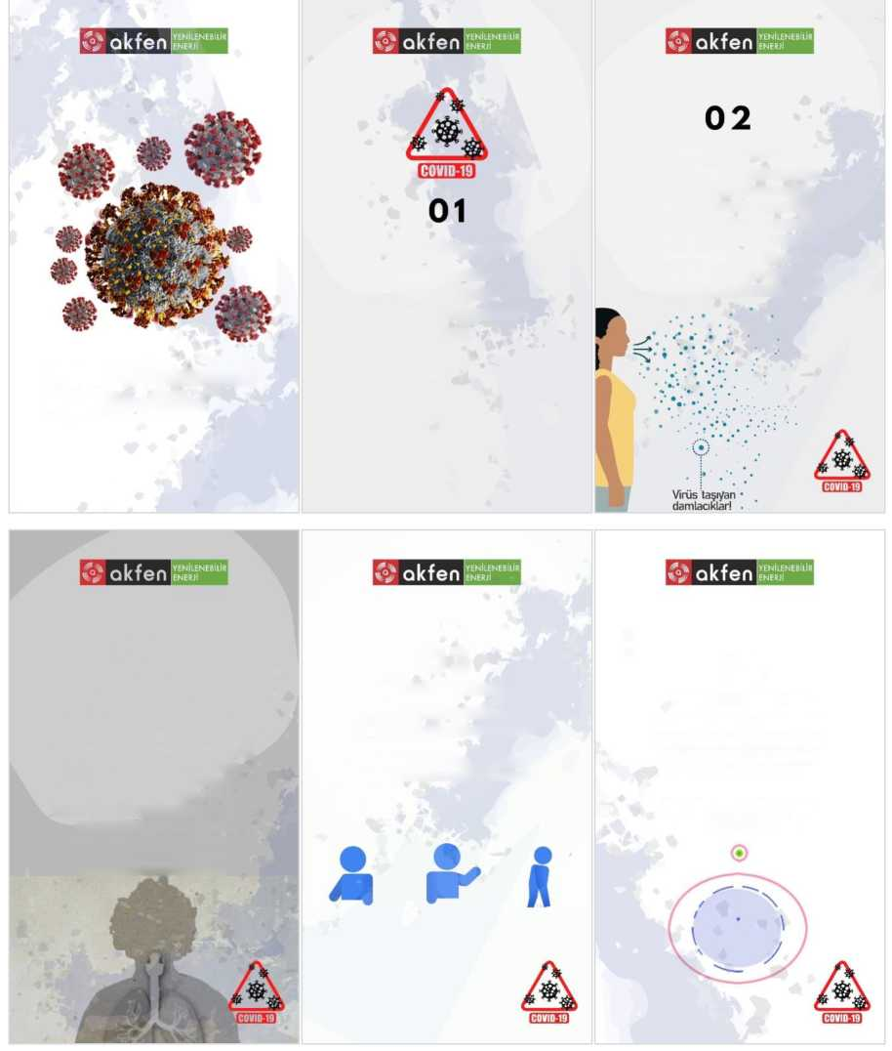

**04**

WHAT IS THE INCUBATION PERIOD?

Incubation time means the time it takes for you to start seeing the first symptoms in yourself after you have received the virus. The incubation period of the new Coronavirus is 2 to 14 days.

**03**

WHAT ARE THEIR SYMPTOMS?

The most common symptoms are fever, coughing and respiratory distress.

In severe cases, pneumonia, severe respiratory insufficiency, renal insufficiency and death may develop.

**02**

HOW IS IT TRANSMITTED?

For contamination to occur;

respiratory outputs carrying the virus must be spread out with sneezing or coughing. In this case, **if you are within a distance of about one meter** or if respiratory secretions (droplets) are transmitted to a lifeless surface and that surface touches another person's bare hand without cleaning and **touches their mouth, eyes, nose without washing** their hands, the virus can enter the bodies of healthy individuals,

Virus-carrying droplets!

HOW IS IT TRANSMITTED?

It can be transmitted by contacting the droplets emitted by the sick people by coughing or sneezing to the mouth, nose and eyes of other individuals in the environment, and by taking the hands to the mouth, nose or eye after touching the surfaces where the droplets stick.

WHAT IS CORONAVIRUS?

The new Coronavirus is a virus that causes respiratory tract infection.

**COVID-19 (Coronavirus) Information Training**

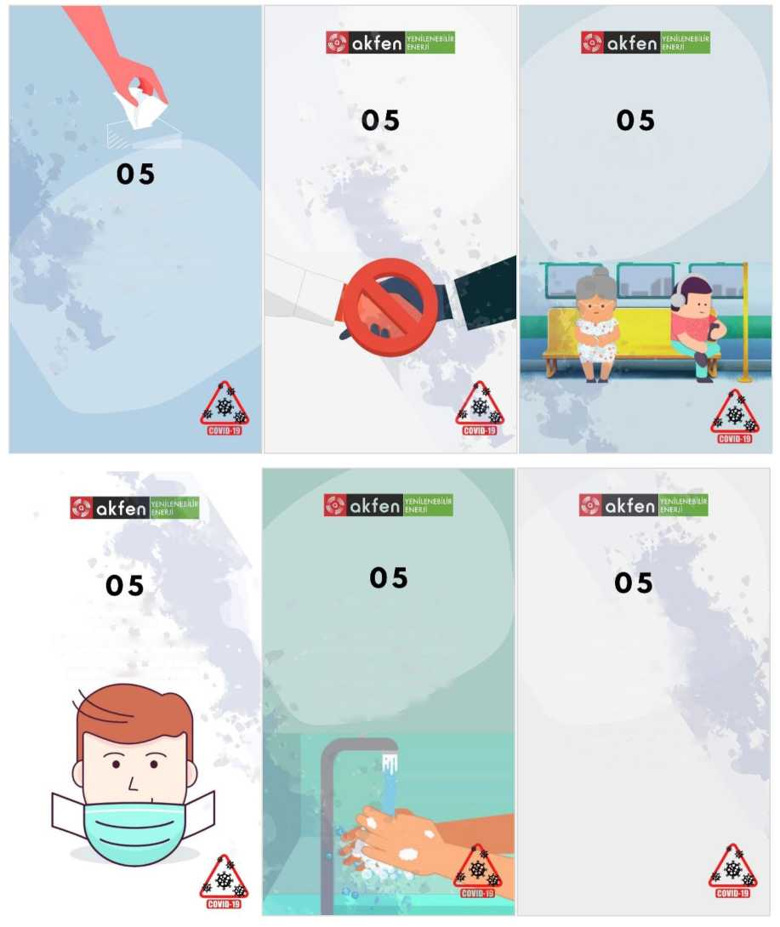

WHAT TO DO TO BE PROTECTED?

Please Click on the **HAND HYGIENE** link previously forwarded to your phones to access the hand-washing video.

This is for your attention again in the appendix to this training!

WHAT TO DO TO BE PROTECTED?

Mouth, nose and eyes **should not be touched with dirty hands.** Care should be attached to hand hygiene. Hands should be washed with soap and water for at least 20 seconds.

WHAT TO DO TO BE PROTECTED?

Use a mask to cover your mouth and nose when you go out.

WHAT TO DO TO BE PROTECTED?

Avoid **crowded environments as much** as possible.

WHAT TO DO TO BE PROTECTED?

Shaking and hugging should be avoided.

WHAT TO DO TO BE PROTECTED?

During coughing or sneezing, the mouth and nose should be closed with a disposable handkerchief, and if there is no handkerchief, the inner part of the elbow should be used.

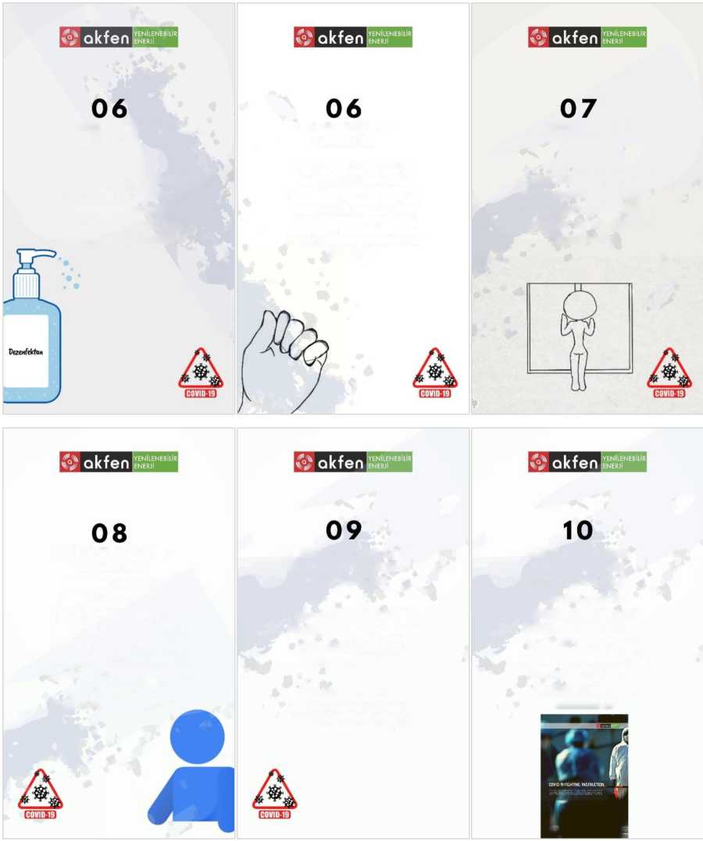

WHAT ARE THE SAFETY MEASURES TAKEN IN OUR PREMISES?

All of our plant safety measures are described in detail in **COVID-19 FIGHTING INSTRUCTION**. You can request this instruction from your Power Plant Manager!

WHAT SHOULD I DO IF MY COLLEAGUES HAVE SYMPTOMS?

Digital; You must complete **and SUBMIT the COVID-19 RISK PERSONNEL FORM** immediately!

The said form is presented to your attention again in the annex of this training!

WHAT TO DO IF THERE ARE SYMPTOMS?

If you are coughing, have a fever and have difficulty breathing, immediately report the situation to your plant manager and workplace physician, and if you do not know the workplace physician contact information, obtain it from your plant manager.

WHAT TO DO TO BE PROTECTED?

Ventilate your workspaces frequently in natural ways. Do not use equipment such as air conditioning, ventilators, etc. unless it is mandatory.

WHAT TO DO TO BE PROTECTED?

**If you experience sensitivity, burning, itching, swelling, etc. in your hands due to disinfectant use, inform your workplace physician immediately**.

WHAT TO DO TO BE PROTECTED?

In cases where there is no soap and water, hand antiseptic/disinfectant containing alcohol should be used. **Hands must be disinfected frequently.**

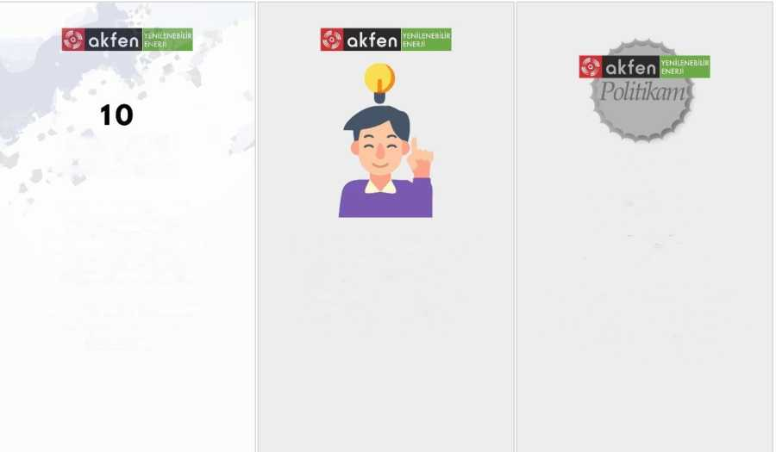

HUMAN RESOURCES

QUALITY

ENVIRONMENT

OCCUPATIONAL HEALTH AND SAFETY

ENERGY EFFICIENCY

SOCIAL RESPONSIBILITY

INFORMATION SECURITY

PERSONAL DATA PROTECTION

All employees assigned to our plants must read our policies. Please take 5 minutes and review our policy texts.

Please review our policies and personal codes listed on the next page and presented to the attention of the public and you, our valuable employees, on our notice boards at all our plants.

WHAT ARE THE SAFETY MEASURES TAKEN IN OUR PREMISES?

If you think that the necessary safety precautions have not been taken in your plants, please inform us with the suggestion/complaint form!

The said form is presented to your attention again in the annex of this training!

Picture 11 DIGITAL FORM HAS BEEN COMMUNICATED TO ALL EMPLOYEES. PRINTED REGULATION IS NOT NECESSARY.

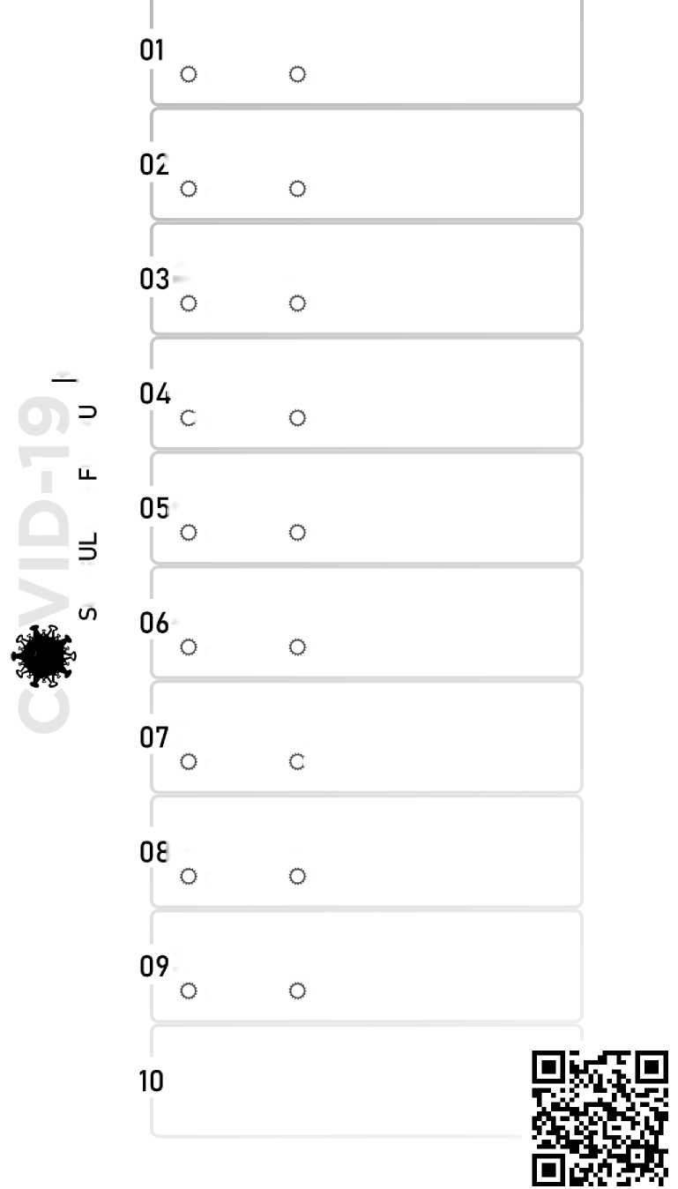

INQUIRY FORM

ANNEX**01**

Has any of your household come from abroad in the last 14 days?

YES NO

Have you or anyone in your household had a table with anyone from abroad in the last 14 days?

YES NO

Have any of your relatives been admitted to the hospital with fever, coughing and difficulty breathing in the last 14 days?

YES NO

Have any of your relatives been diagnosed with CORONA (COVID-19) in the last 14 days?

YES NO

Are there any individuals in your family who enter crowded environments due to necessity and drive public vehicles?

YES NO

Among your family members, how many individuals have to get out of the house due to their work (other than you)

YES NO

Do you feel that the necessary measures have been taken within the scope of the fight against CORONA in your premises?

YES NO

Did your premises provide training in the fight against CORONA? Or have you been briefed?

YES NO

Did your Occupational Physician and OHS Specialist work on the fight against CORONA?

YES NO

How often do you go out of work?

ANNEX **02** **CHEMICALS TO BE USED FOR SURFACE CLEANING AND DISINFECTION**

In particular, surfaces with a high number of users such as doors, windows, cabinet handles should be cleaned with the chemicals listed below in the morning, afternoon and evening hours.

Table 1 CHEMICALS TO BE USED IN ENVIRONMENTAL CLEANING

|  |  |  |  |
| --- | --- | --- | --- |
| **CLEANING CHEMICAL CONTENT** | **AREA OF USE** | **ADVANTAGES** | **DISADVANTAGES** |
| STANDARD BLEACH.  (at 1:10 normal dilution) (Sodium hypochlorite CAS number: 7681-52-91) | Surfaces contaminated with blood and body fluids | • Easy to access/supply  • Ready to use  • Wipes and sprays available  • Sporicidal and viral (Kills spores and viruses) | • Harmful to metal equipment.  • Deactivated by organic materials (Therefore surfaces must be cleaned before use).  • Irritant to skin and mucous membranes.  • To be used within 24 hours of reconstitution.  • Can paint clothes. |
| STANDARD BLEACH.  (at normal dilution 1:100) (Sodium hypochlorite CAS number: 7681-52-9) | General surface cleaning |
| Hydrogen peroxide (0,5%)  (CAS number: 7722- 84-1) | External surfaces of equipment | • Safe for the environment  • Not toxic  • Active in the presence of organic matter  • Wipes and liquid form available  • Excellent cleaning capability due to its detergent property | • Harmful to copper, zinc, brass, acrylic and aluminium. |
| Cologne containing at least 70% alcohol | Hand cleaning | • Sporicidal and viral (Kills spores and viruses)  • It is volatile, does not feel wet on the hand. | • Volatile, severe mass loss if not properly closed. |
| Alcohol or Ethanol-based disinfectants | Hand cleaning | • Sporicidal and viral (Kills spores and viruses) | • May cause poisoning if swallowed! |

**1** CAS NO-CHEMICAL REGISTRATION NUMBER

Appendix**03** OPERATIONS TO BE DESIGNED IN WORKSHOP

Picture 12 POSTER DESIGN OF GENERAL FIELD WORKING INFORMATION (TO BE INSTALLED IN POWER PLANT BUILDINGS)

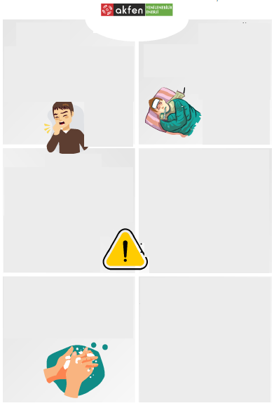

***FAQs***

***Is there a vaccine?***

***The vaccine for this disease has not yet been developed!***

***Is there a cure?***

***There is no direct disease-oriented treatment at this time!***

***What is the disease causing?***

***Many people infected by this virus have developed pneumonia.***

***When are the symptoms of the disease seen?***

***Virus-induced symptoms are seen in an average of 14 days.***

***Who are the mortality rate and risky mass?***

***2% - Elderly and those with chronic diseases***

HAND WASHING

*Please wash your hands* *thoroughly for at least 20 seconds up to your elbows, wash your hands thoroughly, between your fingers, under your nails*.

*CAUTIONS 01*

*This virus has been seen in our country. The best way to prevent the infection is to avoid exposure to this virus. Simple daily preventive actions are available to help prevent the spread of respiratory viruses. These include;*

*• Do not approach people who are sick*

*• Do not enter crowded environments unless you have to*

*• Do not touch your face with unwashed hands.*

*• Wash your hands with soap for at least 20 seconds.*

*• Cover your cough and sneeze with a tissue.*

*• Clean frequently contacted objects and surfaces.*

*• Do not share your personal belongings*

*WARNING*

*If you have these symptoms, contact a hospital immediately, inform your workplace doctor and supervisor by phone without wasting time; act in accordance with your supervisor's instructions*

*Do not come to your work area without notice!*

*SYMPTOMS*

*Mild or severe softening pathway disorders in patients with Corona virus (2O19-nCoV)*

*Fever*

*Cough*

*Shortness of breath*

*SPREAD OF THE DISEASE*

*It occurs with respiratory droplets produced when a sick person coughs or sneezes. It is like flu and respiratory diseases. When a person touches a surface or object with a virus on* it, *and then touches his own aga, nose, or possibly his eyes, he also gets sick.*

Coronavirus

Information

Picture 13 INFORMATION FOR MANAGERS POSTER DESIGN (TO BE RECOMMENDED IN MANAGEMENT OFFICES)

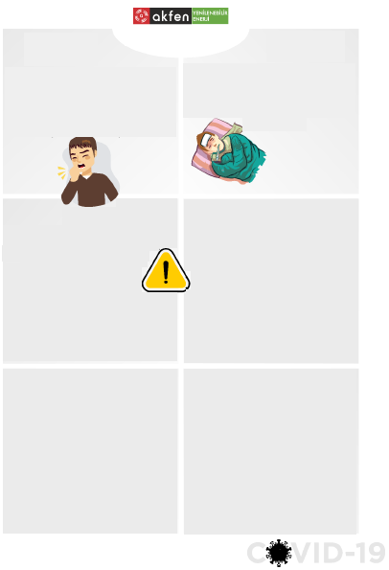

*PERSONAL MEASURES*

*This virus has been seen in our country. The best way to prevent the infection is to avoid exposure to this virus. Simple daily preventive actions are available to help prevent the spread of respiratory viruses. These include;*

*• Do not approach people who are sick*

*• Do not enter crowded environments unless you have to*

*• Do not touch your face with unwashed hands.*

*• Wash your hands with soap for at least 20 seconds.*

*• Close the product, take a pill with a tissue,*

*• Clean frequently contacted objects and surfaces.*

*• Don't share your personal belongings*

***FAQs***

***Is there a vaccine?***

***The vaccine for this disease has not yet been developed!***

***Is there a cure?***

***There is no direct disease-oriented treatment at this time!***

***What is the disease causing?***

***Many people infected by this virus have developed pneumonia.***

***When are the symptoms of the disease seen?***

***Virus-induced symptoms are seen in an average of 14 days.***

***Who are the mortality rate and risky mass?***

***2% - Elderly and those with chronic diseases***

*INSTITUTIONAL MEASURES*

*• Temperature measurement of both our employees and everyone coming from outside will be performed at the entrance to the offices/work areas and disinfectants at the entrance counters will be used. Those with a fever**of**38° or higher will be directed to health institutions for protection. In the event that relationships that an employee is infected occur while working in the office during the day, a mask has been supplied to him/her to wear and protect our other employees until he/she is referred to the hospital and will be distributed to our office buildings and businesses/workplaces.*

*• Periodic disinfection of our conflict correspondents; periodic wiping and disinfection of common areas such as offices, meeting rooms, toilets, measures are taken in our central offices regarding washing dishes in machines at 60°C and the same measures will be taken in all our workplaces/businesses.*

*WARNING*

*If you have these symptoms, contact a hospital immediately, inform your workplace doctor and supervisor by phone without wasting time; act in accordance with your supervisor's instructions*

Until *further* notice*,*

*• Do not prefer airline transportation,*

*• Remember to wear a protective mask if you go abroad* (FFP1 with *Valve Filter),*

• *Follow your situation for 14 days if you have come from abroad, do not come to work during this time (remember to get a health report),*

*• The amount and duration of the meeting should be shortened, and participation should be ensured by teleconference if possible,*

*• Avoid contact in the office environment, take care to greet remotely*

*SPREAD OF THE DISEASE*

*It occurs with respiratory droplets produced when a sick person coughs or sneezes. It is like flu and respiratory diseases. When a person touches a surface or object with a virus on* it, *and then touches his own aga, nose, or possibly his eyes, he also gets sick.*

*SYMPTOMS*

*Mild or severe softening pathway disorders in patients with Corona virus (2O19-nCoV)*

*Fever*

*Cough*

*Shortness of breath*

Coronavirus

Information

*.*

*.*

Picture 14 THIS INSTRUCTION WILL BE KEPT IN ALL VEHICLES!



**Annex04**

**CORONATIONS REGARDING TO DRIVING**



|  |  |
| --- | --- |
| 01 | Disposable gloves and masks shall be kept in their packaging inside the vehicles. |
| 02 | Cologne and/or chemical disinfectants with an alcohol content of over 80% shall be kept in the vehicles. |
| 03 | Disposable wipes containing chemical disinfectant shall be kept in the vehicles. |
| 04 | Frequently touched surfaces of vehicles shall be cleaned with disinfectants before driving. |
| 05 | Multiple individuals should not travel in vehicles unless they are obliged to. |
| 06 | If it is necessary for more than one person to travel in vehicles; disposable gloves, face mask and protective glasses shall be used. Passengers will travel by the windowsills (e.g. 3rd party travel will not be allowed in the rear seats of the vehicle) and disposable gloves and mask will be disposed of in the medical waste bin after the journey and the glasses will be disinfected with chemicals. (Multi-use personal protective equipment should be cleaned after and before each use!) |
| 07 | It has to be ensured that the hands are not touched to the face during driving and that the hands are immediately cleaned with disinfectants and washed as soon as possible. |
| 08 | During vehicle use, internal ventilation and air conditioning systems will not be used, windows will be kept open as much as possible and the indoor environment will be ventilated. The indoor environment of the vehicle will not be allowed to remain airless. |
| 09 | Individuals traveling within the vehicle will be asked to make as little contact with the vehicle as possible with their hands. The driver will inform travellers on this when necessary. |
| 10 | After vehicle use, all windows of the vehicles will be opened, and ventilation will be provided for at least 10 minutes inside the vehicle and it will be cleaned with in-vehicle disinfectants. Detailed cleaning will be tried to be performed especially on the surfaces where there is a lot of contact. Cleaning shall be carried out by an individual travelling. |
| 11 | Individuals who do not act in accordance with the rules will be taken out of the vehicle and written warning will be requested by warning the responsible managers. |

Picture 15 DIGITAL FORM / RISK PERSONNEL DETERMINATION FORM

**Annex05**

RISK PERSONNEL DETERMINATION FORM

|  |  |
| --- | --- |
| REGISTRATION DATE/TIME | -----/-----/2----- ----: ---- |
| RECORDED BY |  |
| PLANT |  |
| THE PERSON YOU SUSPECT IS SICK |  |
| YOUR REASONS | □ HIGH FEVER □ SHORTNESS OF BREATH  □ PERSISTENT COUGH □ OTHER |

FEVER LEVEL -------------°C



Figure 16-MONTH COVID-19 INQUIRY QUESTION -<https://forms.gle/MCvimEJZ8m43Y9T69>

|  |
| --- |
| COVID-19 INQUIRY  INFORMATION YOU TAKE WITH THIS FORM IS IMPORTANT FOR THE HEALTH OF YOU AND YOUR OTHER COLLEAGUES. PLEASE DISPLAY SENSITIVITY WHILE ANSWERING THE QUESTION!  * Required |
|  |
| Name Surname *  NAME IS MANDATORY!  Your Answer |
| Select the plant where you work. *  Select▼ |
| Has any of your household come from abroad in the last 14 days? *  O YES  O NO |
| Have you or anyone in your household had any contact with anyone abroad in the last 14 days? *  O YES  O NO |
| Have any of your relatives been admitted to the hospital with fever, coughing and difficulty breathing in the last 14 days? *  O YES  O NO |
| Have any of your relatives been diagnosed with CORONA (COVID-19) in the last 14 days? *  O YES  O NO |
| Are there any individuals in your family who enter crowded environments due to necessity and drive public vehicles? *  O YES  O NO |

|  |
| --- |
| Among your family members, how many individuals have to get out of the house because of their work (other than you) *  O NONE  O Other |
|  |
| What is being done in your plant in the fight against CORONA *   * SANITARY SINK IS AVAILABLE * COLOGNE IS AVAILABLE * HAND DISINFECTANT IS AVAILABLE * FEVER CONTROL IN WORK * MASK IS AVAILABLE (DISPOSABLE) * GLOVES ARE AVAILABLE (DISPOSABLE) * SAFETY GOGGLES ARE AVAILABLE * WORKING AREA IS VENTILATED FREQUENTLY * FIELD DISINFECTION IS PERFORMED * Other: |
|  |
| Did your Occupational Physician and OHS Specialist work on the fight against CORONA? *  O YES  O NO |
|  |
| How often do you go out of work? *  Your Answer |

|  |  |
| --- | --- |
| Please tick if you have any of the following diseases! | |
| 🞏 | Chronic Lung Disease |
| 🞏 | Diabetes (Diabetes) |
| 🞏 | High Blood pressure (Hypertension) |
| 🞏 | Chronic Hepatic Disease |
| 🞏 | Chronic Kidney Disease |
| 🞏 | Chronic cardiac |
| 🞏 | Genetic Discomfort |
| 🞏 | I take regular rheumatism medication or painkillers |
| 🞏 | Blood cancer (hematological cancer) |
| 🞏 | Other Types of Cancer (solid cancer) |
| 🞏 | I am undergoing chemotherapy |
| 🞏 | Immune System Disorder |
| 🞏 | I am cortisone therapy. |
|  | |
| Please report any suggestions and complaints regarding the process of combating CORONA here? | |
| Your Answer | |
|  | |

Next  Page 1 / 3

**Annex06** AMBIENT DISENSFECTION INSTRUCTION

Picture 17 DISINFECTION INSTRUCTION (TO BE INSTRUCTED IN ALL SITES)

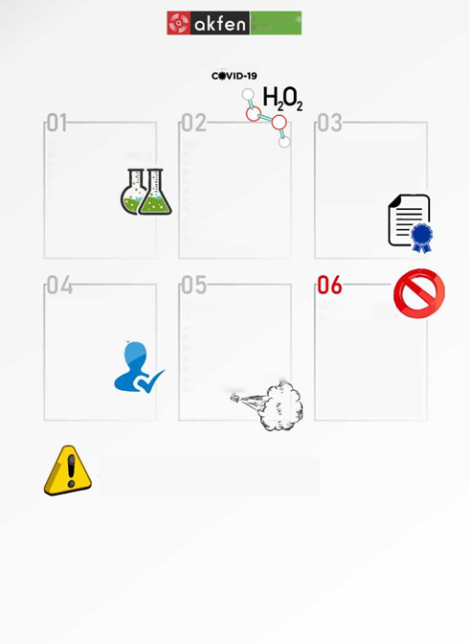

Other matters to be considered with caution

• Pure disinfectants should be diluted at recommended rates before use,

• All parts that can be separated from the materials to be disinfected have to be separated,

• The duration of action of disinfectants should be well known and the recommended contact time should be followed,

• The date on which the solution is prepared should be written, no outdated solution should be used.

• As the disinfectant solution decreases, it should not be added.

• Solutions should be kept closed at all times,

* In case of visible contamination of the solution, the solution should be replaced without waiting for the expiry date.

* Gloves, apron and mask should be worn when performing the procedure.

Devices used in disinfection for viruses and bacteria should never have been previously disposed of insecticides (pesticides). When insecticides and virus disinfectants are combined, both effective first decreases and components dangerous to human health may occur.

Disinfectants should be applied with an electric ULV device. These devices ionize disinfectants and release them into the air in the form of steam, which provides a more effective fight against airborne and surface viruses.

The personnel to be applied must have BIOCIDAL PRODUCT APPLICATIONPERMIT

The company to implement should have a BIOCIDAL PRODUCT APPLICATION PERMIT obtained from the Public Health Directorate.

Hydrogen peroxide is a substance that is highly active in microorganisms, bacteria, fungi, viruses and spores. It is a non-toxic compound. Stabilized forms are durable for a long time. 7.5% liquid solution provides a high level of disinfection in 10 minutes. It is used at a density of 1-3% for general cleaning and disinfection .

Hydrogen peroxide, hypochlorites,UV-C lamps rveozone can be used for disinfection against Coronavirus-Covid-19.

DISINFECTION INSTRUCTION

**Renewable energy**

Figure 18 COVID-19 EMERGENCY ACTION PLAN

 EMERGENCY ACTION PLAN

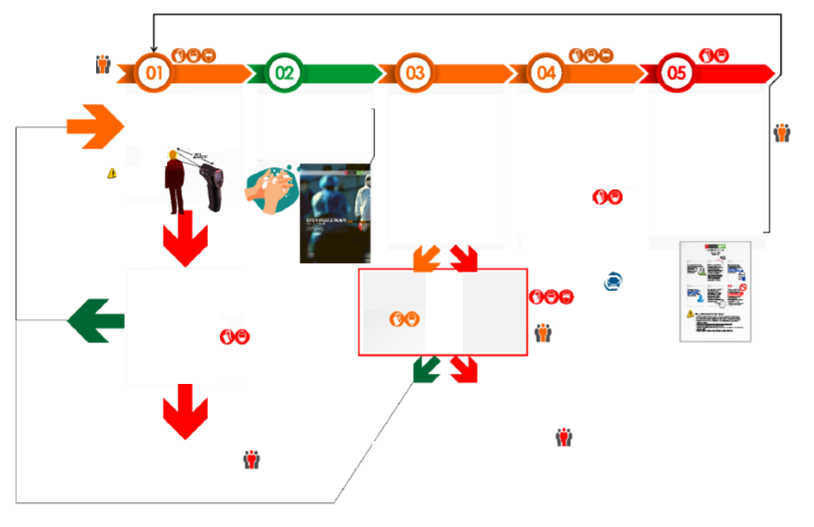

The process will be followed up by the on-site physician and the Plant Manager will be informed periodically

**Annex04**

**CORONA PRECAUTIONS FOR DRIVING**

The driver will be equipped with the necessary PPE!

POSITIVE COVID-19 TEST RESULT (+)

Quarantine and treatment process started

The driver will be subjected to COVID-19 TEST and act in accordance with the emergency service instructions.

NEGATIVE AS A RESULT OF COVID-19 TEST {-)

Diagnosed with cold, etc., and treatment was performed.

The process will be followed up by the on-site physician and the Plant Manager will be informed periodically

The process will be followed up by the on-site physician and the Plant Manager will be informed periodically

Unless the suspicious person is not in a position to drive. A staff member signing the SPECIAL TRANSFER REQUIREMENT CONSENT will take the suspected individual to the emergency department and follow up the situation in the emergency department until the test results are obtained and inform the Workplace Physician and the Power Plant Manager by phone,

If the suspect individual is able to drive, no other employee will be put at risk and the personnel will be asked to go to the emergency department with the allocated vehicle!

The process will be followed up by the on-site physician and the Plant Manager will be informed periodically

POSITIVE COVID-19 TEST RESULT (+)

Quarantine and treatment process started

SUSPICIOUS CASE ASSESSMENT

Any of the following situations have been detected!

* Fever above 38OC

* Continuous coughing

• Distinct sweating

• Difficulty breathing

• DISPOSABLE MASK AND GLOVES THAT WILL NOT BE ALLOWED TO ENTER THE SITE WILL BE WORN AND REQUESTED TO BE TRANSFERRED TO THE EMERGENCY DEPARTMENT.

• COVID-19 PERSONNEL IDENTIFICATION FORM SHALL BE COMPLETED IMMEDIATELY BY USING MOBILE PHONE.

• THE PLANT MANAGER AND THE WORKPLACE PHYSICIAN WILL BE INFORMED.

POSITIVE (+) AS A RESULT OF THE COVID-19 TEST IN SUSPECIAL

• ALL EMPLOYEES IN THE POWER PLANT WILL BE REFERRED TO EMERGENCY SERVICES WITH COVID-19 SUSPICION.

• PERSONNEL WHO WILL WORK IN OTHER SHIFTS WILL BE INFORMED BY PHONE AND WILL BE REQUESTED NOT COME TO WORK UNTIL FURTHER NOTICE.

• ALL RELEVANT PARTIES SEEN IN THE ORGANIZATIONAL CHART WILL BE INFORMED VIA CORPORATE E-MAIL.

• THE ENTIRE PLANT SITE SHALL ALSO BE DISINFECTED IN ACCORDANCE WITH THE DISINFECTION INSTRUCTIONS.

• THE CONTINUITY OF THE ACTIVITIES WILL BE ENSURED WITH THE INDIVIDUALS WHO HAVE NEGATIVE (-) TEST RESULTS AND, WHERE NECESSARY, TEMPORARY PERSONNEL.

COVID-19 PHASE AMONG THE EMPLOYEES

If there are employees who cannot be determined during entry control but who show significant symptoms after starting to work (postponement, chills, difficulty breathing, cough, etc.), a temperature measurement will be performed immediately. Even if the fever is normal, the person in question;

• IT SHALL BE TRANSFERRED TO THE COVID-19 SUSPECTED AREA SPECIFIED IN THE WORKING SITE WITH DISPOSABLE HAND AND MASK.

• COVID19 RISK PERSONNEL TESPİT FORM SHALL BE COMPLETED IMMEDIATELY BY USING MOBILE PHONE.

• INFORM THE PLANT MANAGER AND PHYSICIAN.

• THE VEHICLE WILL BE PREPARED AND IT WILL BE ENSURED THAT THE PERSON IN QUESTION IS REFERRED TO THE EMERGENCY DEPARTMENT AS SOON AS POSSIBLE.

UNTIL THE TEST RESULTS ARRIVE

After the detection of the suspect, necessary cleaning procedures will be carried out immediately, especially the surfaces contacted by the suspect will be carefully cleaned and the objects such as water etc. used by the suspect will be immediately discarded, and the personal items such as cups, cups etc. used by the suspect will be cleaned by means of a dishwasher.

All employees will wait separately until the test result arrives. In the meantime, personal cleaning will be engaged.

All personnel will be equipped with the necessary PPE!

NEGATIVE (-) AS A RESULT OF THE SUSPECIAL COVID-9 TEST

Normal working order will be started

Cleaning performer shall be equipped with the necessary PPE!

All personnel will be equipped with the necessary PPE!

NEGATIVE AS A RESULT OF COVID-19 TEST {-)

Diagnosed with cold, etc., and treatment was performed.

SITE ACCEPTANCE AND STARTING OF WORK

Complying fully with hand cleaning and other hygiene rules at the entrance in accordance with COVID-19 COMBAT INSTRUCTION requirements.

Filling out the forms transmitted over the mobile phone without losing time, examining the training videos and visuals.

Measurement distance (max)

SURFACE TO SCAN

THERMAL CAMERA shall be used in case it is found in the field!

ENTRANCE CONTROL

The further the infrared measuring devices are removed from the surface, the greater the error rate is achieved. It is required for accurate measurement to be kept close to the surface to be measured. It is recommended to measure from a distance of approximately 20 cm, (No contact with the individual, no contact with the device!

Access control shall be performed by Security Officers. Training should be provided for these personnel regarding the use of the relevant measuring devices.

The inspector shall be equipped with the necessary PPE!

Annex**07 REQUIRED CONTROL LIST FOR EVALUATION OF RISKS CREATED by COVID-19 IN WORK AREAS 2**

Table 2 GENERAL EVALUATION QUESTIONS

|  |  |  |
| --- | --- | --- |
| **NO** | **EVALUATION QUESTIONS** | **CONTROL** |
| 01 | Are all employees and contractors aware of the actions proposed by WHO to reduce the risk of Covid-19transmission? | □ |
| 02 | Have you developed a Covid-19 action plan in your business that is tailored to your work?   * 3COVID-19 COMBAT INSTRUCTION Rev.02 - 26.06.2020 | ⌧ |
| 03 | Is there an additional resource required to support the implementation of measures against Covid-19?   * External service is required to fulfill DISINFECTION INSTRUCTION requirements. (Disinfection activities) | ⌧ |
| 04 | Has someone working in your business been selected to ensure the effective implementation of Covid-19 measures in your action plan?   * The Power Plant Manager is responsible for the fulfillment of the COVID 19 COMBAT INSTRUCTION requirements. This is described in the scope of the instruction. | ⌧ |
| 05 | Do you inform your employees, subcontractors, visitors and Employer about Covid-19?   * CORONAVIRUS information posters have been installed in all our plants. (Design Drawing 6). In addition, all our employees,   1. our plants have been trained by appointed workplace physicians.  2. They have been trained in hygiene through mobile phones.  <https://forms.gle/gfE6FfJomUVdW7vv6> | ⌧ |
| 06 | Do you use a specific method of communication at a certain frequency? | □ |
| 07 | Training for employees and contractors is provided? For example; how to use PPE against Covid-19.   * COVID-19 trainings are provided to the employees and external personnel via their mobile phones. In addition to the training of workplace physicians, employees are planned to be trained within the scope of the training content transmitted to their mobile phones. | ⌧ |

**2** This study has been prepared in compliance with EBRD's information note dated April 15, 2020. The answers of the businesses to the questions in the checklist will provide objective support by AKFEN Yenilenebilir® in evaluating the adequacy of the measures taken by the business against theCOVID-19 virus.

The questions in this checklist may, over time, be reduced or increased by AKFEN Renewable® based on medical developments in theCOVID-19 virus. With this study, Akfen Energy aims to eliminate or minimize the harms of COVID-19 virus in the study areas.

* **3** DESCRIPTIONS - ANSWERS

|  |  |  |
| --- | --- | --- |
| 08 | Are employees trained on proposed actions, hazards, risks and control measures related toCovid-19?   * All employees have been trained by assigned workplace physicians in our plants. * All our employees were provided with training slides within THE scope of AKFEN Renewable® Education Library (mobile). Additional field trainings are planned within the framework of the said training presentations. | ⌧ |
| 09 | Can some tasks with a risk of Covid-19 infection be avoided? If unavoidable, can it be changed to reduce the risk of employee exposure (remote operation, phased operation, etc.)?   * Within the framework of this instruction, it is forbidden for those at risk of COVID-19 to enter the power plant site regardless of their duties and positions. During this period, the existing personnel infrastructure and, where necessary, temporary additional personnel employment will be on the agenda. | ⌧ |
| 10 | Do employees need to undertake their duties differently by changing your existing procedures and instructions?   * No changes have been made in the mission contents and fulfillment methods within the plant operation process. | □ |
| 11 | Sufficient audit is conducted by employees and sub-contractors to monitor the correct implementation of revised working methods and new procedures?   * COVID-19 FIGHTING INSTRUCTION conditions 2. The party is questioned within the audit program. (Monthly/3-month audit periods) | ⌧ |
| 12 | Is information on additional safety rules and how to apply them required?   * Additional security measures are not deemed necessary under current conditions. So far, no employees have been diagnosed with COVID-19. | □ |
| 13 | Have you identified high-risk or vulnerable employees in terms of Covid-19 and taken appropriate measures to protect them?   * A survey study was conducted to determine the risks of COVID-19 of our employees (COVID- 19 INQUIRIES [https://forms.gle/GZDT6baznW5Sxszt5).](https://forms.gle/GZDT6baznW5Sxszt5) This questionnaire is communicated to all employees on a monthly basis. The contents of the survey are listed below.   o Factors influencing the risk of transmission  o COVID-19 general information  o List of measures taken at work sites. | ⌧ |
| 14 | Need to collaborate with any local organizations or local public health authorities?   * It is not considered necessary under the current circumstances. | □ |

Table 3 CLEANING AND DISINFECTION CONTROL

|  |  |  |
| --- | --- | --- |
| **NO** | **EVALUATION QUESTIONS** | **CONTROL** |
| 01 | Have existing cleaning systems been modified to account for the risk ofCovid-19?   * COVID-19 CONTROL INSTRUCTION Additional cleaning instructions (chemicals to be used and application techniques) are specified in Annex II. | ⌧ |
| 02 | Are cleaning frequencies sufficient for risk in specific work areas and common contact points?   * COVID-19 FIGHTING INSTRUCTION; “Employer Responsibilities” 24. The cleaning operations carried out with the chemicals specified in Annex II are considered to be adequate. | ⌧ |
| 03 | Is there adequate cleaning and antiviral material available for all work areas?   * Whether cleaning and hygiene chemicals specified in COVID-19 CONTROL INSTRUCTION are available in sufficient quantities in all sites is questioned during field inspections. In addition, our employees are given the opportunity to make suggestions and complaints about disinfectant and required amount of PPE (mask, salt, gloves). (Mobile link:<https://forms.gle/GayRrgCPTEJtZDye8>) | ⌧ |
| 04 | Does the plan take into account what measures should be taken if appropriate cleaning supplies are insufficient (e.g. only in critical areas)?   * Cleaning agents are not expected to be insufficient. Therefore, this was not considered in the risk analyses. | □ |
| 05 | Do cleaning workers use different working methods that reduce contact with surfaces to avoid risk? And is it supported to use correct PPE during cleaning?   * Necessary information and warning signs have been installed about the use of PPE. Apart from this, it was not deemed necessary to develop different working methods. | □ |
| 06 | Have common touchpoints such as handrails, door handles, lifting buttons been identified? Are new measures necessary to prevent contact?   * Additional measures other than routine cleaning and disinfectant facility are not deemed necessary. | □ |
| 07 | Have disinfection points been clearly described to employees, subcontractors, and visitors with adequate signs?   * Suitable announcement posters have been designed and installed for all disinfection points (Picture 4) | ⌧ |
| 08 | Is good respiratory hygiene encouraged? And are there appropriate disposal options for used paper cleaning products in the workplace?   * COVID-19 FIGHTING INSTRUCTION; “Employer Responsibilities” 13. Article and Picture 2 GENERAL WORKING RULES AGAINST PANDEMIC as stated in POSTER, special boxes have been established for wastes such as PPE and disposable tissues used only against the pandemic in all working areas. | ⌧ |
| 09 | Are working service vehicles within the scope of increasing cleaning methods? And does the social distancing rule apply to these vehicles?   * The use of a service vehicle is not in question. The rules for the use of company vehicles are set out in the COVID-19 FIGHTING INSTRUCTION, “Annex IV Corona Measures for Vehicle Use”. This instruction is available in all vehicles. | ⌧ |

Table 4 HAND CLEANING

|  |  |  |
| --- | --- | --- |
| **NO** | **EVALUATION QUESTIONS** | **CONTROL** |
| 01 | Do you encourage regular and comprehensive hand washing of employees, subcontractors and visitors in your workplace?   * Training presentations/videos about hand washing are delivered to our employees via mobile phones. In addition, there are many poster designs and facilities related to the importance of hand washing in the working areas.   Link:<https://forms.gle/tZciW9PBtN98X92m9> | ⌧ |
| 02 | Is there sufficient washing point with hot water assembly and soap?   * Adequate and appropriate sinks have been installed in all sites. | ⌧ |
| 03 | Are there remote areas where hand washing is not possible?   * The areas where hand washing is not possible are listed below.   o Open areas (production points - Turbine, panel plant areas, transformer, etc.) disinfectant is kept in company vehicles.  o Landfill sites  Disinfectant is kept in warehouses.  COVID-19 FIGHTING INSTRUCTION; “Employer Responsibilities” 11. Article: | ⌧ |
| 04 | Do employees, contractors and visitors have hand washing points before entering offices or other buildings?   * Hand washing is not possible at the entrances of the control building, therefore disinfectant and warning signs have been installed.   COVID-19 FIGHTING INSTRUCTION; “Employer Responsibilities” 11. Article: | □ |

Table 5 MULTI-PURPOSE USES

|  |  |  |
| --- | --- | --- |
| **NO** | **EVALUATION QUESTIONS** | **CONTROL** |
| 01 | Are risks considered in lodging and/or lodging and/or working dining areas and/or toilets and/or areas such as showers?   * There is no lodging. Except in emergency situations, it is forbidden to stay in the control buildings. Additional rules have been determined for the kitchen and dining halls established within the control buildings. These rules have been put on poster and hung on the walls in these areas. (COVID-19 FIGHTING INSTRUCTION Picture 8 KITCHEN/ADDITIONAL RULES FOR FOOD HOSPITALS) | ⌧ |
| 02 | Are social distancing rules applied in these areas?   * COVID-19FIGHTING INSTRUCTION is explained in the “Employee Responsibilities" section and is specified in the general working rules posters. (Picture 2 GENERAL WORKING RULES AGAINST PANDEMIC POSTER DESIGN) | ⌧ |
| 03 | Are places where the social distancing rule cannot be applied, recreational areas and other similar places closed?   * There is no closure of resting areas. There are no sites that are closed or restricted in our power plants provided that they comply with the rules already determined (except for the areas that are restricted in accordance with the safety rules). | □ |
| 04 | Has the risk of Covid-19 transmission been reduced in office areas?   * These risks have been reduced with the measures taken within the scope of COVID-19 CONTROL INSTRUCTION. | ⌧ |
| 05 | Can nearby table layout be avoided? Keyboards and other devices are disinfected on a regular basis?   * There is no close-up table layout. The issue of continuous disinfection of equipment such as keyboards, phones etc. is described in the chapter "Employee Responsibilities” ofCOVID-19 FIGHTING INSTRUCTION. | ⌧ |
| 06 | Can employees work from home? And can Skype, Zoom, FaceTime and similar portals be used for meetings?   * There is no remote operation option for power plants. AKFEN renewable Head Office meetings are held under ZOOM Platform. | ⌧ |
| 07 | Are other trainings other than critical trainings postponed to a later date?   * During the trainings, the rules of social distance and mask use are observed.   The maximum number of participants is 4. In this context, plant employee trainings started as of June 2020. | □ |
| 08 | Can crowded meetings involving employees, subcontractors and visitors be avoided?   * There is no need for a crowded meeting. In case of emergence of such an organization need, priority is given to platforms such as ZOOM, and such organizations are avoided unless it is necessary. | ⌧ |

Table 6 Personal PROTECTIVE EQUIPMENT

|  |  |  |
| --- | --- | --- |
| **NO** | **EVALUATION QUESTIONS** | **CONTROL** |
| 01 | Is PPE4 considered as a last resort and used in addition to other control measures?   * All the safety measures determined for the power plant sites are specified in theCOVID-19 FIGHTING INSTRUCTION. The said instruction has been sent to all our plants with THE "HIGH LEVEL OF IMPORTANCE" code and put into operation. Within the scope of the integrated management system continuous improvement principle, this instruction is reviewed and revised and developed. | ⌧ |
| 02 | Have the PPE required for employees, subcontractors and visitors been given to those at greatest risk?   * A sufficient number of disposable masks are kept within the power plant sites for all employees and visitors. | ⌧ |
| 03 | Have risk assessments been reviewed and PPE required for each task identified?   * A risk analysis study specific to COVID-19 was carried out. | ⌧ |
| 04 | Are existing PPE the right choice for risks? And does it provide the protection needed?   * The current situation shows that the measures taken, and the personal protective equipment determined are appropriate. There are no employees diagnosed with COVID-19 so far. | ⌧ |
| 05 | Have the international standards and technical standards used for PPE been reviewed to verify protection factors such as disposal times?   * 2. Within the scope of the party surveillance, the requirements of COVID-19FIGHTING INSTRUCTION are questioned and reviewed during the monthly 3-month field inspections. | ⌧ |
| 06 | Does the respiratory protection equipment (SKD) provide the correct protection factor, e.g. FFP3, FFP2?   * Use of ASGARI N95/FFP2 MASK is provided as a minimum in our work areas. | ⌧ |
| 07 | Have the employees received the necessary training for the PPE they will use and have appropriate compliance tests been carried out?   * Our employees are provided with COVID 19 training and training on the use of personal protective equipment by the Workplace Physician appointed in all our plants. | ⌧ |
| 08 | Is PPE changed periodically and disposed of appropriately?   * Disposable masks and gloves are used. The conditions of “Circular 2020/12 on Covid-19 Measures in the Management of Personal Hygiene Material Wastes such as Disposable Masks and Gloves" are taken into account in the storage and disposal of such PPE. | ⌧ |
| 09 | Does the Emergency Action Plan take into account the necessary actions in case PPE are insufficient? And which employees' PPE was considered critical for use?   * Situations where the use of PPE is critical are indicated on the emergency action plan. | ⌧ |

Table 7 MEDICAL SURVEILLANCE

|  |  |  |
| --- | --- | --- |
| **NO** | **EVALUATION QUESTIONS** | **CONTROL** |
| 01 | Are employees informed of all potential symptoms of Covid-19 disease?   * COVID-19 trainings are provided to the employees and external personnel via their mobile phones. In addition to the training of workplace physicians, employees are planned to be trained within the scope of the training content transmitted to their mobile phones. | ⌧ |
| 02 | Are all employees suitable to work for the job? Or were they told to stay home?   * The situations in which the employees should stay at home have been reported verbally and in writing. | ⌧ |
| 03 | Is it confirmed that the employees are medically well? Ex: are observations or physical checks carried out by the workplace physician at work?   * There is no additional workplace physician examination work within the scope of the pandemic. | □ |
| 04 | Is there an emergency procedure in place for employees with suspectedCovid-19 symptoms in the workplace?   * Within the scope of COVID-19FIGHTING INSTRUCTION, Figure 16 COVID-19 EMERGENCY ACTION PLAN has been prepared and put into operation. To date, no emergencies have been encountered in this context. | ⌧ |
| 05 | Are medical arrangements in the study area sufficient for your business?   * The measures taken within the scope of COVID-19 FIGHTING INSTRUCTION are reviewed in the light of the security measures determined by the Ministry of Health of the Republic of Turkey and its adequacy is questioned. It has been concluded that the measures in question are sufficient so far. | ⌧ |
| 06 | Do you need to assess first aid needs and increase first aid provisions?   * COVID-19 FIGHTING INSTRUCTION; “Employee Responsibilities” 22. As stated in clause, First Aiders must use all COVID-19 PPE(mask, gloves, goggles) during the intervention. This situation shall also be indicated in the emergency action plans. | ⌧ |
| 07 | Do you provide protection for paramedics?   * PPE allocated to our employees will also be used for first aiders. When the need for first aid and balance risks are evaluated, additional PPE etc. for first aiders (Special clothing, etc.) facility is not deemed necessary. | ⌧ |
| 08 | Do employees know the location of local medical centers in their area?   * Within the framework of OHS Emergency Action Plans, close hospitals and access roads are known by employees. | ⌧ |
| 09 | Do you have a sufficient number of first aid workers or emergency responders, and a sufficient number of employees if some fall ill?   * In case of sickness of the personnel, there is not sufficient number of personnel employment in order to maintain the current working order. In case such a situation is encountered, additional overtime and temporary personnel employment options shall be evaluated in order to fulfill the mandatory duties. | ⌧ |

Table 8 EMERGENCY STATUS PLANNING

|  |  |  |
| --- | --- | --- |
| **NO** | **EVALUATION QUESTIONS** | **CONTROL** |
| 01 | Are there emergency preparedness measures? Are many employees at risk of contractingCovid-19? Within the scope of Q COVID-19FIGHTING INSTRUCTION, Figure 16 COVID-19 EMERGENCY ACTION PLAN has been prepared and put into operation. To date, no emergencies have been encountered in this context.   * There is a risk that 2 employees for GES plants and 4 employees for RES plants may get sick at the same time. | ⌧ |
| 02 | Is there a communication plan in place to inform all key stakeholders? Are public health centres included in this?   * COVID-19 FIGHTING INSTRUCTION Annex 8 COVID-19 COMMUNICATION INSTRUCTION is activated. | ⌧ |
| 03 | Can the works continue safely despite its impact on your business?   * When the power plant operation process is taken into consideration, it is predicted that the conditions of COVID-19 FIGHTING INSTRUCTION are not fulfilled, the coercive effects are low, and the works can be continued by taking these safety measures. | ⌧ |
| 04 | Are employees in critical positions identified and do you have appropriate measures? Are these employees protected to ensure continuity?   * Due to the low number of employees, all our employees are evaluated in critical status. | ⌧ |
| 05 | Do you have an announcement to make if you are aware of an employee who has Covid-19?   * COVID-19 FIGHTING INSTRUCTION The institutions and persons specified in Annex 8 COVID-19COMMUNICATION INSTRUCTION shall be informed. Other than that, there is no announcement. | □ |
| 06 | Have your locking procedures been improved if the project is closed?   * The possibility of termination, closure and freezing of the project is not in question at the moment. | □ |
| 07 | If locking is required, are the procedures to be performed secure? Need additional support from local law enforcement?   * The possibility of termination, closure and freezing of the project is not in question at the moment. | □ |
| 08 | If an incident occurs in the field, are the local emergency services and the response facilities you will provide with your own facilities sufficient?   * There are no additional needs within the framework of the designated emergency action plan. | ⌧ |
| 09 | Should you avoid some high-risk work due to the decrease in emergency services during this period?   * All of our activities are in place, a situation that should be avoided and work is not at stake at the moment. | □ |

Table 9 LOCAL PEOPLE

|  |  |  |
| --- | --- | --- |
| **NO** | **EVALUATION QUESTIONS** | **CONTROL** |
| 01 | Have you informed neighbouring businesses and local people about theCovid-19 controls and measures you have adopted in your business? | □ |
| 02 | Do you have a new system for delivering food or other materials? Are the services or products you receive from local communities and other suppliers? | □ |
| 03 | Can the local people be protected from an infected employee? | □ |
| 04 | Are employee movements and interaction with locals restricted? | □ |
| 05 | Are there restrictions to prevent the social gathering of local workers? | □ |
| 06 | Are there procedures in place for local communities, employees engaged in activities that may be considered risky behavior, and employees who may be subjected to verbal or physical abuse during work? | □ |